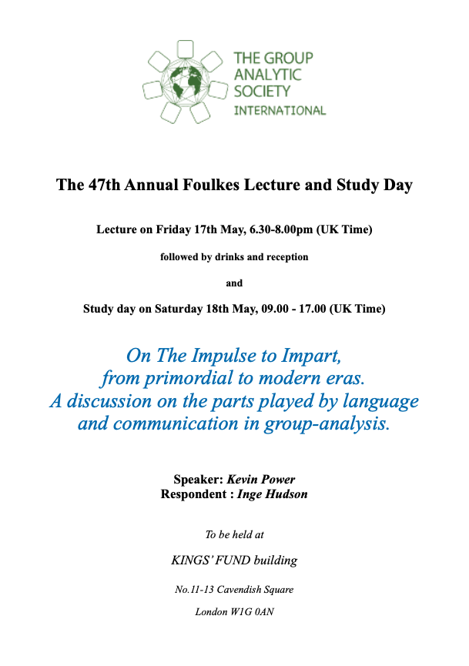

" ‘On The Impulse to Impart’ is about communication and language. Communication is a fundamental group-analytic theme and one on which S H Foulkes laid great and repeated emphasis. I look at their parts in group-analysis, how they may have originated and evolved and at an experiment that appears to confirm Foulkes' belief in language being the defining human attribute." (Kevin Power).

Foulkes Lecture:
18.00 Registration – Welcome

18.30 Lecture:

Speaker: Kevin Power
Respondent: Inge Hudson

Questions and Answers

20:00 – 21.30 Drinks Reception

Study Day:
9:30 – 11:00 Large Group:
Teresa Von Sommaruga Howard- Anando Chatterji
Carla Penna (online)
11:00 – 11:30 Coffee break
11:30 – 12:45 Responses + dialogue:
Catherine Mela
Felix Korf
12:45 – 13:45 Lunch break
13:45 – 15:00 Reflection groups
15:00 – 15:30 Tea/coffee break
15:30 – 17:00 Large Group
17:00 – 17:15 Closure

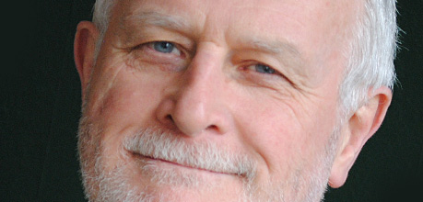
Speakers:

Kevin Power, Group Analyst, psychotherapist in 1984 with the London Centre for Psychotherapy. IGA’s Certificate in Group-analytic Supervision in 2003. GAS and GASI as Hon. Secretary, Hon Treasurer, Hon Archivist, Exec Editor of the Journal and Chairperson of the 2011 London Symposium.

Inge Hudson is a retired group analyst and a clinical psychologist. She has extensive experience as a practitioner with groups and individuals within the NHS, at the Women’s Therapy Centre, London and in private practice. She has taught on a number of training courses for psychologists and psychotherapists in the UK and in Germany and was a training group analyst for the IGA and G.R.A.S. in Germany.

Catherine Mela MD, is a group analyst, trainer, neurologist with specification on psychoneuroimmunology. She is the f.Vice President of IAGP , founder and chair of the IAGP Research Comittee (2012-2024).She lives and works in Athens, Greece.

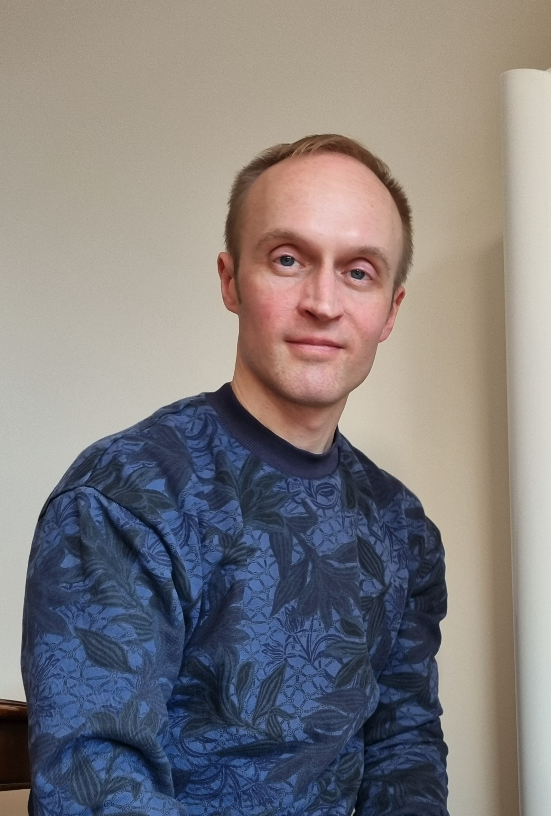

Felix Korf is a group analyst and a specialist in psychosomatic medicine, currently also training in psychiatry. He lives and works in Wiesbaden/Frankfurt, Germany.

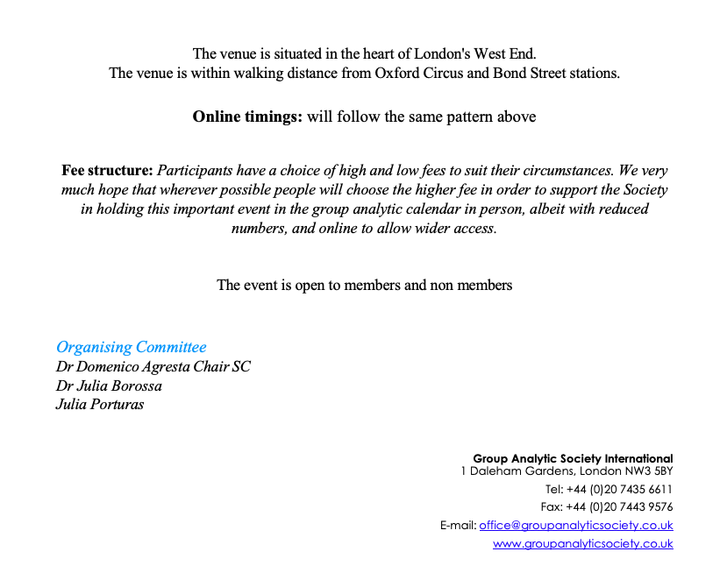

More info and a download-able map here:
https://www.11cavendishsq.com/find-us/

For further information and how to register please go to our website:
https://groupanalyticsociety.co.uk

